**Purpose**

The purpose of this panel is to display the possibility of adjusting the state(s) of an object depending on the state of another object.

**Research Conducted**

Seeing as I began to understand the basics of the software, I didn’t need to conduct research to gain an understanding of any features prior to beginning the panel. The bit of research I did conduct was to settle for a design for the panel, and what features to include. For this I downloaded more sample projects from the Uniqo website to draw inspiration.

**Outcome**

**Project View**

**Window (no adjustments made)**

**Warning and Danger Level Values Added**

**Slider Ranges Updated**

**Invalid Input Box Values Render Update Button Unclickable**

**Design Decisions**

* To showcase the possibility to modify the state of objects depending on the state of another object, I decided to include 3 LED’s. The flashing of the LED’s depend on the value of the slider (E.g.: If the slider value is not within the warning or danger range, the green LED will flash, and so on).
* To add some complexity to the panel and to build on the previous panel, I included input boxes to allow for the modification of the warning and danger ranges on the slider.
* Through the use of NetLogic, once the user adjusts the slider ranges, the LED’s will update automatically. So if the user changes the warning range to 10-35, the orange LED will start flashing once the slider is within that range.

**Findings & Considerations**

A strange behaviour I encountered during the process of this panel is sometimes when the user inputs a margin value for an object (E.g.: 100px left margin to a button), the software changes this to a -100px right margin. This hasn’t caused me any issues other than some confusion.

The use of NetLogic makes such functionality like seen above fairly straightforward to create. FT Optix makes it easy to assign objects to variables inside NetLogic files through a drag-and-drop interface

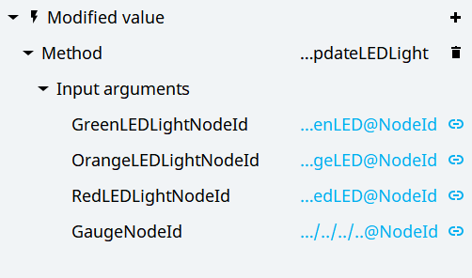

The finding of elements when writing unit tests is currently a fairly challenging task. For example, the slider is made up of multiple different objects (SVGs, divs, & spans.) but they don’t have a unique identifier to navigate to them through the use of XPaths directly. The only solution to this (currently) is long, specific XPath’s which will have a tendency to break if the panel was to be modified.